<https://ceds.deq.virginia.gov/ui#wqmFieldDatas/129515>

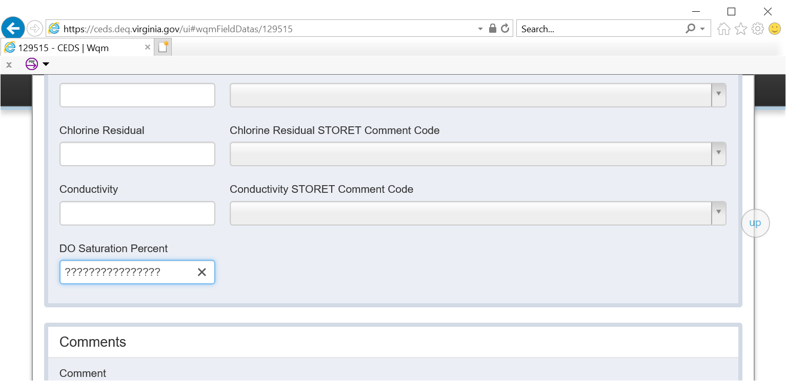

SAS CODE

SET CL=FDT_SALINITY/**1.80655**;

**PROC** **SQL**; ALTER TABLE WORK.FDT ADD DOSAT NUM FORMAT **3.2** LABEL = 'DOSAT' ;**QUIT**;

**PROC** **SQL**; UPDATE WORK.FDT SET FDT_DO_PROBE = FDT_DO_OPTICAL WHERE FDT_DO_OPTICAL IS NOT NULL;

**PROC** **SQL**;

UPDATE WORK.FDT

SET DOSAT= (FDT_DO_PROBE/EXP(-**139.34411**+(**1.575701**\***100000**/(FDT_TEMP_CELCIUS+**273.15**))-

(**6.642308**\***10000000**/((FDT_TEMP_CELCIUS+**273.15**)*(FDT_TEMP_CELCIUS+**273.15**)))+

(**1.243800**\***10000000000**/((FDT_TEMP_CELCIUS+**273.15**)*(FDT_TEMP_CELCIUS+**273.15**)*(FDT_TEMP_CELCIUS+**273.15**)))-

(**8.621949**\***100000000000**/((FDT_TEMP_CELCIUS+**273.15**)*(FDT_TEMP_CELCIUS+**273.15**)*(FDT_TEMP_CELCIUS+**273.15**)*

(FDT_TEMP_CELCIUS+**273.15**)))-

CL*((**3.192900**\***0.01**)-(**1.942800**\***10**/(FDT_TEMP_CELCIUS+**273.15**))+

(**3.867300**\***1000**/((FDT_TEMP_CELCIUS+**273.15**)*(FDT_TEMP_CELCIUS+**273.15**))))))\***100**

WHERE FDT_DO_PROBE IS NOT NULL

AND CL IS NOT NULL

AND FDT_TEMP_CELCIUS IS NOT NULL;